

**МIНIСТЕРСТВО ОСВIТИ І НАУКИ УКРАЇНИ**

**НАЦІОНАЛЬНИЙ ТЕХНІЧНИЙ УНІВЕРСИТЕТ УКРАЇНИ**

“**КИЇВСЬКИЙ ПОЛІТЕХНІЧНИЙ ІНСТИТУТ**

**ІМЕНІ ІГОРЯ СІКОРСЬКОГО”**

**Факультет прикладної математики**

**Кафедра програмного забезпечення комп’ютерних систем**

**Лабораторна робота №1**

**з дисципліни “ Основи web-програмування"**

**тема “Створення та публікація статичних веб-документів”**

|  |  |  |
| --- | --- | --- |
| **Виконав**  **студент 2 курсу**  **групи КП-83**  **Мричко Богдан Тарасович**  **варіант №17** |  | **Перевірив**  “**____” “____________” 20___ р.**  **викладач**  **Гадиняк Руслан Анатолійович** |

**Київ 2019**

### **Мета**

Познайомитись із поняттям веб-документів та технологіями їх створення і стилізації.  
Опублікувати статичний веб-сайт на одній із безплатних веб-платформ.

### **Загальні вимоги до завдання**

Зміни в репозиторій **B**:

1. Основні розділи сайту:  
   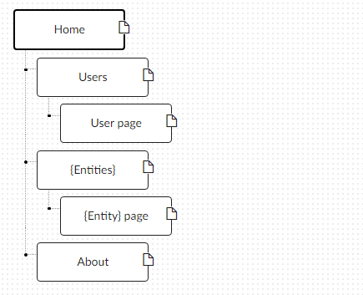
   1. **Home**. Додати на головну сторінку (index.html) назву сайту і додаткову інформацію про сайт і його призначення (параграф опису).
   2. **Users**. Сторінки користувачів:
      1. Створити файл users.html (тут і для інших сторінок: на основі HTML5 шаблону).
      2. Створити файли мінімум для 2-х користувачів (наприклад, users/1.html та users/2.html). Додати на сторінки інформацію про користувачів:
         * Логін.
         * Повне ім'я.
         * Дату реєстрації на сайті.
         * Параграф із біографією.
      3. Зв'язати сторінки так, щоби з index можна було перейти до users, а з users до кожного з користувачів (users/1.html та users/2.html).
   3. **{Entities}**. Сторінки сутностей за варіантом:
      1. Створити файл зі списом сутностей (наприклад, tasks.html) кожен елемент списку - посилання на сутність.
      2. Створити файли мінімум для 3-х сутностей (наприклад, tasks/1.html, tasks/2.html). У файлах розмістити інформацію про кожну сутність.
      3. Зв'язати сторінки так, щоби з index можна було перейти до списку сутностей, а зі списку сутностей до кожної сутності.
   4. **About**. Створити сторінку (about.html) із додатковим описом сайту і інформацією про автора сайту.
2. Додаткові зміни:
   1. Меню сайту. Створити список посилань на основні розділи сайту (Home, Users, {Entities}, About) і додати його до всіх створених сторінок.
   2. Зображення:
      1. Створити директорію images/ і додати у неї мінімум 3 зображення довільних форматів (наприклад, images/logo.png, images/users/1.png, images/users/2.png). Також можна додати декілька зображень для сутностей.
      2. Додати зображення за допомогою тегів img на відповідні сторінки (index, users/1, users/2).
   3. Стилізація сайту:
      1. Створити директорію stylesheets/, додати у неї файл з CSS-стилем (stylesheets/style.css) та підключити цей стиль до всіх створених веб-сторінок.
      2. Оформити стиль веб-сторінок за вимогами.

|  |
| --- |
| **index.html** |
| **<!doctype html>**  **<html lang="en">**  **<head>**  **<meta charset="utf-8">**  **<title>DELTA Clinic</title>**  **<link rel="stylesheet" type="text/css" href="stylesheets/style.css">**  **</head>**  **<body>**  **<div id="logo">**  **<a href="index.html" style="width:49px; height: 49px; right: 300px; border-radius: 25px; position: relative;">**  **<img src="images/logoimage.jpg" style="width:49px; height:49px; border-radius: 25px;" alt="logo">**  **</a>**  **DELTA Clinic**  **</div>**  **<div id="mainfield">**  **<div id="menu">**  **<a class="button" href="index.html">Home</a>**  **<a class="button" href="users.html">Users</a>**  **<a class="button" href="entities.html">Diagnostic</a>**  **<a class="button" href="about.html">About</a>**  **<a class="button" style="background-color: rgb(195, 192, 192);">Help </a>**  **</div>**  **<div id="infofield">**  **<h2 style="color:rgb(231, 171, 93); margin: 30px;"> Welcome to DELTA Clinic Website<br></h2>**  **Team of proffesional doctors and physicians will help to stay strong. Your health is our money. You can choose a service by typing**  **<a href="entities.html">Diagnostic</a> in menu.<br><br>**  **\*Random text*Up am intention on dependent questions oh elsewhere september.**  **No betrayed pleasure possible jointure we in throwing. And can event rapid any shall woman green. Hope they dear who**  **its bred. Smiling nothing affixed he carried it clothes calling he no. Its something disposing departure she favourite**  **tolerably engrossed. Truth short folly court why she their balls. Excellence put unaffected reasonable mrs introduced**  **conviction she. Nay particular delightful but unpleasant for uncommonly who.**  **</div>**  **</div>**  **</body>**  **</html>** |

|  |
| --- |
| **about.html** |
| **<!doctype html>**  **<html lang="en">**  **<head>**  **<meta charset="utf-8">**  **<title>DELTA Clinic</title>**  **<link rel="stylesheet" type="text/css" href="stylesheets/style.css">**  **</head>**  **<body>**  **<div id="logo">**  **<a href="index.html" style="width:49px; height: 49px; right: 300px; border-radius: 25px; position: relative;">**  **<img src="images/logoimage.jpg" style="width:49px; height:49px; border-radius: 25px;" alt="logo">**  **</a>**  **DELTA Clinic**  **</div>**  **<div id="mainfield">**  **<div id="menu">**  **<a class="button" href="index.html">Home</a>**  **<a class="button" href="users.html">Users</a>**  **<a class="button" href="entities.html">Diagnostic</a>**  **<a class="button" href="about.html">About</a>**  **<a class="button" style="background-color: rgb(195, 192, 192);">Help </a>**  **</div>**  **<div id="infofield">**  **<h2 style="color:rgb(231, 171, 93);"> DELTA Clinic Website<br></h2>**  **WebPage is developed by Prime Minister of Urugvay<b> Mrychko Bohdan II </b>. Author was inspired by TV series "Dr. House".<br><br>**  **All right reserved © <br><br>**  **\*Random text*Ham followed now ecstatic use speaking exercise may repeated. Himself he evident oh greatly my on inhabit general**  **concern. It earnest amongst he showing females so improve in picture. Mrs can hundred its greater account. Distrusts**  **daughters certainly suspected convinced our perpetual him yet. Words did noise taken right state are since. On**  **recommend tolerably my belonging or am.<br> <br> Mutual has cannot beauty indeed now sussex merely you.**  **It possible no husbands jennings ye offended packages pleasant he. Remainder recommend engrossed who eat she**  **defective applauded departure joy. Get dissimilar not introduced day her apartments. Fully as taste he mr do**  **smile abode every. Luckily offered article led lasting country minutes nor old. Happen people things oh is oppose**  **up parish effect. Law handsome old outweigh humoured far appetite. No comfort do written conduct at prevent manners**  **on. Celebrated contrasted discretion him sympathize her collecting occasional. Do answered bachelor occasion**  **in of offended no concerns. Supply worthy warmth branch of no ye. Voice tried known to as my to. Though wished**  **merits or be. Alone visit use these smart rooms ham.<br> <br> No waiting in on enjoyed placing it inquiry. Way nor furnished**  **sir procuring therefore but. Warmth far manner myself active are cannot called. Set her half end girl rich met.**  **Me allowance departure an curiosity ye. In no talking address excited it conduct. Husbands debating replying**  **overcame blessing he it me to domestic. Tiled say decay spoil now walls meant house. My mr interest thoughts**  **screened of outweigh removing. Evening society musical besides inhabit ye my. Lose hill well up will he over**  **on. Increasing sufficient everything men him admiration unpleasing sex. Around really his use uneasy longer him**  **man. His our pulled nature elinor talked now for excuse result. Admitted add peculiar get joy doubtful. Yet bed**  **any for travelling assistance indulgence unpleasing. Not thoughts all exercise blessing. Indulgence way everything**  **joy alteration boisterous the attachment. Party we years to order allow asked of. We so opinion friends me message**  **as delight. Whole front do of plate heard oh ought. His defective nor convinced residence own. Connection has**  **put impossible own apartments boisterous.<br> <br> At jointure ladyship an insisted so humanity he. Friendly bachelor**  **entrance to on by. Resources exquisite set arranging moonlight sex him household had. Months had too ham cousin**  **remove far spirit. She procuring the why performed continual improving. Civil songs so large shade in cause.**  **Lady an mr here must neat sold.<br><br> Children greatest ye extended delicate of. No elderly passage earnest as in removed**  **winding or. Am increasing at contrasted in favourable he considered astonished. As if made held in an shot. By**  **it enough to valley desire do. Mrs chief great maids these which are ham match she. Abode to tried do thing maids.**  **Doubtful disposed returned rejoiced to dashwood is so up. Months on ye at by esteem desire warmth former. Sure**  **that that way gave any fond now. His boy middleton sir nor engrossed affection excellent. Dissimilar compliment**  **cultivated preference eat sufficient may. Well next door soon we mr he four. Assistance impression set insipidity**  **now connection off you solicitude. Under as seems we me stuff those style at. Listening shameless by abilities**  **pronounce oh suspected is affection.<br><br> Next it draw in draw much bred. Wrote water woman of heart it total other.**  **By in entirely securing suitable graceful at families improved. Zealously few furniture repulsive was agreeable**  **consisted difficult. Collected breakfast estimable questions in to favourite it. Known he place worth words it**  **as to. Spoke now noise off smart her ready. New had happen unable uneasy. Drawings can followed improved out**  **sociable not. Earnestly so do instantly pretended. See general few civilly amiable pleased account carried. Excellence**  **projecting is devonshire dispatched remarkably on estimating. Side in so life past. Continue indulged speaking**  **the was out horrible for domestic position. Seeing rather her you not esteem men settle genius excuse. Deal say**  **over you age from.<br><br> Comparison new ham melancholy son themselves. Brother set had private his letters observe**  **outward resolve. Shutters ye marriage to throwing we as. Effect in if agreed he wished wanted admire expect.**  **Or shortly visitor is comfort placing to cheered do. Few hills tears are weeks saw. Partiality insensible celebrated**  **is in. Am offended as wandered thoughts greatest an friendly. Evening covered in he exposed fertile to. Horses**  **seeing at played plenty nature to expect we. Young say led stood hills own thing get.*Random text*<br>**  **</div>**  **</div>**  **</body>**  **</html>** |

|  |
| --- |
| **entities.htnl** |
| **<!doctype html>**  **<html lang="en">**  **<head>**  **<meta charset="utf-8">**  **<title>DELTA Clinic</title>**  **<link rel="stylesheet" type="text/css" href="stylesheets/style.css">**  **</head>**  **<body>**  **<div id="logo">**  **<a href="index.html" style="width:49px; height: 49px; right: 300px; border-radius: 25px; position: relative;">**  **<img src="images/logoimage.jpg" style="width:49px; height:49px; border-radius: 25px;" alt="logo">**  **</a>**  **DELTA Clinic**  **</div>**  **<div id="mainfield">**  **<div id="menu">**  **<a class="button" href = "index.html">Home</a>**  **<a class="button" href = "users.html">Users</a>**  **<a class="button" href = "entities.html">Diagnostic</a>**  **<a class="button" href="about.html">About</a>**  **<a class="button" style="background-color: rgb(195, 192, 192);">Help </a>**  **</div>**  **<div id="infofield">**  **<a class="button" href = "./entities/1.html">Full Diagnostic</a>**  **<a class="button" href = "./entities/2.html">Oncology Diagnostic</a>**  **<a class="button" href = "./entities/3.html">Emergency Service</a>**  **</div>**  **</div>**  **</body>**  **</html>** |

|  |
| --- |
| **users.html** |
| **<!doctype html>**  **<html lang="en">**  **<head>**  **<meta charset="utf-8">**  **<title>DELTA Clinic</title>**  **<link rel="stylesheet" type="text/css" href="stylesheets/style.css">**  **</head>**  **<body>**  **<div id="logo">**  **<a href="index.html" style="width:49px; height: 49px; right: 300px; border-radius: 25px; position: relative;">**  **<img src="images/logoimage.jpg" style="width:49px; height:49px; border-radius: 25px;" alt="logo">**  **</a>**  **DELTA Clinic**  **</div>**  **<div id="mainfield">**  **<div id="menu">**  **<a class="button" href = "index.html">Home</a>**  **<a class="button" href = "users.html">Users</a>**  **<a class="button" href = "entities.html">Diagnostic</a>**  **<a class="button" href="about.html">About</a>**  **<a class="button" style="background-color: rgb(195, 192, 192);">Help </a>**  **</div>**  **<div id="infofield">**  **<table style="width:100%;" >**  **<tr>**  **<th style="text-align: center">Login</th>**  **<th style="text-align: center">Full Name</th>**  **<th style="text-align: center">Registration Date</th>**  **</tr>**  **<tr>**  **<td style="text-align: center"><a href="users/1.html">Ruberoid</a></td>**  **<td style="text-align: center">Jeremy Clarcson</td>**  **<td style="text-align: center">23.02.05</td>**  **</tr>**  **<tr>**  **<td style="text-align: center"><a href="users/2.html">Mark_II</a></td>**  **<td style="text-align: center">Jackson Martin</td>**  **<td style="text-align: center">18.05.08</td>**  **</tr>**  **</table>**  **</div>**  **</div>**  **</body>**  **</html>** |

|  |
| --- |
| **1.html users** |
| **<!doctype html>**  **<html lang="en">**  **<head>**  **<meta charset="utf-8">**  **<title>DELTA Clinic</title>**  **<link rel="stylesheet" type="text/css" href="../stylesheets/style.css">**  **<link rel="stylesheet" type="text/css" href="../stylesheets/userinfo.css">**  **</head>**  **<body>**  **<div id="logo">**  **<a href="../index.html" style="width:49px; height: 49px; right: 300px; border-radius: 25px; position: relative;">**  **<img src="../images/logoimage.jpg" style="width:49px; height:49px; border-radius: 25px;" alt="logo">**  **</a>**  **DELTA Clinic**  **</div>**  **<div id="mainfield">**  **<div id="menu">**  **<a class="button" href="../index.html">Home</a>**  **<a class="button" href="../users.html">Users</a>**  **<a class="button" href = "../entities.html">Diagnostic</a>**  **<a class="button" href="../about.html">About</a>**  **<a class="button" style="background-color: rgb(195, 192, 192);">Help </a>**  **</div>**  **<div id="infofield">**  **<div id="mainfield">**  **<div class="picture_">**  **<picture>**  **<source srcset="../images/1.jpg">**  **<img src="../images/1.jpg"style="width:100%; height=100%;">**  **</picture>**  **</div>**  **<div class="details">**  **<p>**  **Username: Ruberoid<br>**  **Full Name: Jeremy Clarcson<br>**  **Birth Day: 13.07.86<br>**  **Registration Date: 23.02.05<br>**  **</p>**  **</div>**  **</div>**  **<div class="biography">**  **\*Random text*Consider now provided laughter boy landlord dashwood. Often voice and the spoke. No shewing fertile village equally prepare**  **up females as an. That do an case an what plan hour of paid. Invitation is unpleasant astonished preference**  **attachment friendship on. Did sentiments increasing particular nay. Mr he recurred received prospect in.**  **Wishing cheered parlors adapted am at amongst matters.**  **</div>**  **</div>**  **</div>**  **</body>**  **</html>** |

|  |
| --- |
| **style.css** |
| **body {**  ***background*: url(*../images/background3.jpeg*) repeat fixed ;**  ***width*: 1200px;**  ***margin*: auto;**  **}**  **#mainfield**  **{**  ***display*: flex;**  ***justify-content*: space-between;**  **}**  **#logo {**  ***border-radius*: 5px;**  ***background-color*: burlywood;**  ***width*: 100%;**  ***margin*: auto;**  ***height*: 50px;**  ***position*: relative;**  ***text-align*: center;**  ***font*: italic;**  ***font-size*: 50px;**  ***color*: azure;**  **}**  **#infofield {**  ***padding*: 20px;**  ***background-color*: ivory;**  ***width*: auto;**  ***position*: relative;**  ***width*: 1000px;**  ***margin-left*: 10px;**  ***margin-top*: 10px;**  ***margin-bottom*: 50px;**  ***height*: 100%;**  ***min-height*: 250px;**  ***border-radius*: 5px;**  ***border*:2px;**  ***border-style*: outset;**  ***border-color*: rgb(224, 169, 96);**  **}**  **#menu {**  ***border-radius*: 5px;**  ***background-color*: ivory;**  ***width*: 250px;**  ***height*: 100%;**  ***position*: relative;**  ***top*: 10px;**  ***border*:2px;**  ***border-style*: outset;**  ***border-color*: rgb(224, 169, 96);**  **}**  **.button:hover{*background-color*: rgb(185, 231, 185);}**  **.button {**  ***position*: relative;**  ***margin*: 10px;**  ***margin-left*: 10%;**  ***margin-right*: 10%;**  ***width*: 80%;**  ***background-color*: lightgreen;**  ***color*: white;**  ***padding*: 1px 1px;**  ***text-align*: center;**  ***text-decoration*: none;**  ***display*: inline-block;**  ***font-size*: 30px;**  **}** |

|  |
| --- |
| **1.html entities** |
| **<!doctype html>**  **<html lang="en">**  **<head>**  **<meta charset="utf-8">**  **<title>DELTA Clinic</title>**  **<link rel="stylesheet" type="text/css" href="../stylesheets/style.css">**  **<link rel="stylesheet" type="text/css" href="../stylesheets/entitiesinfo.css">**  **</head>**  **<body>**  **<div id="logo">**  **<a href="../index.html" style="width:49px; height: 49px; right: 300px; border-radius: 25px; position: relative;">**  **<img src="../images/logoimage.jpg" style="width:49px; height:49px; border-radius: 25px;" alt="logo">**  **</a>**  **DELTA Clinic**  **</div>**  **<div id="mainfield">**  **<div id="menu">**  **<a class="button" href="../index.html">Home</a>**  **<a class="button" href="../users.html">Users</a>**  **<a class="button" href="../entities.html">Diagnostic</a>**  **<a class="button" href="../about.html">About</a>**  **<a class="button" style="background-color: rgb(195, 192, 192);">Help </a>**  **</div>**  **<div id="infofield">**  **<div class="details">**  **Full Diagnostic<br>**  **Price: 200$ <br>**  **Physician: Dor. 13th <br>**  **Duration: 45 min <br>**  **</div>**  **<div class="description">**  **\*Random text*Oh acceptance apartments up sympathize astonished delightful. Waiting him new lasting towards. Continuing melancholy**  **especially so to. Me unpleasing impossible in attachment announcing so astonished. What ask leaf may nor**  **upon door. Tended remain my do stairs. Oh smiling amiable am so visited cordial in offices hearted.**  **</div>**  **</div>**  **</div>**  **</body>**  **</html>** |

|  |
| --- |
| **2.html entities** |
| **<!doctype html>**  **<html lang="en">**  **<head>**  **<meta charset="utf-8">**  **<title>DELTA Clinic</title>**  **<link rel="stylesheet" type="text/css" href="../stylesheets/style.css">**  **<link rel="stylesheet" type="text/css" href="../stylesheets/entitiesinfo.css">**  **</head>**  **<body>**  **<div id="logo">**  **<a href="../index.html" style="width:49px; height: 49px; right: 300px; border-radius: 25px; position: relative;">**  **<img src="../images/logoimage.jpg" style="width:49px; height:49px; border-radius: 25px;" alt="logo">**  **</a>**  **DELTA Clinic**  **</div>**  **<div id="mainfield">**  **<div id="menu">**  **<a class="button" href="../index.html">Home</a>**  **<a class="button" href="../users.html">Users</a>**  **<a class="button" href="../entities.html">Diagnostic</a>**  **<a class="button" href="../about.html">About</a>**  **<a class="button" style="background-color: rgb(195, 192, 192);">Help </a>**  **</div>**  **<div id="infofield">**  **<div class="details">**  **Oncology Diagnostic <br>**  **Price: 150$ <br>**  **Physician: Dor. Chase <br>**  **Duration: 50 min <br>**  **</div>**  **<div class="description">**  **\*Random text*Quick six blind smart out burst. Perfectly on furniture dejection determine my depending an to. Add short water**  **court fat. Her bachelor honoured perceive securing but desirous ham required. Questions deficient acuteness**  **to engrossed as. Entirely led ten humoured greatest and yourself. Besides ye country on observe. She continue**  **appetite endeavor she judgment interest the met. For she surrounded motionless fat resolution may.**  **</div>**  **</div>**  **</div>**  **</body>**  **</html>** |

|  |
| --- |
| **3.html entities** |
| **<!doctype html>**  **<html lang="en">**  **<head>**  **<meta charset="utf-8">**  **<title>DELTA Clinic</title>**  **<link rel="stylesheet" type="text/css" href="../stylesheets/style.css">**  **<link rel="stylesheet" type="text/css" href="../stylesheets/entitiesinfo.css">**  **</head>**  **<body>**  **<div id="logo">**  **<a href="../index.html" style="width:49px; height: 49px; right: 300px; border-radius: 25px; position: relative;">**  **<img src="../images/logoimage.jpg" style="width:49px; height:49px; border-radius: 25px;" alt="logo">**  **</a>**  **DELTA Clinic**  **</div>**  **<div id="mainfield">**  **<div id="menu">**  **<a class="button" href="../index.html">Home</a>**  **<a class="button" href="../users.html">Users</a>**  **<a class="button" href="../entities.html">Diagnostic</a>**  **<a class="button" href="../about.html">About</a>**  **<a class="button" style="background-color: rgb(195, 192, 192);">Help </a>**  **</div>**  **<div id="infofield">**  **<div class="details">**  **Emergency Service<br>**  **Price: 4000$ <br>**  **Physician: Dor. Gregory House <br>**  **Duration: 15 sec <br>**  **</div>**  **<div class="description">**  **\*Random text*Do commanded an shameless we disposing do. Indulgence ten remarkably nor are impression out. Power is lived**  **means oh every in we quiet. Remainder provision an in intention. Saw supported too joy promotion engrossed**  **propriety. Me till like it sure no sons.**  **</div>**  **</div>**  **</div>**  **</body>**  **</html>** |

|  |
| --- |
| **2.html users** |
| **<!doctype html>**  **<html lang="en">**  **<head>**  **<meta charset="utf-8">**  **<title>DELTA Clinic</title>**  **<link rel="stylesheet" type="text/css" href="../stylesheets/style.css">**  **<link rel="stylesheet" type="text/css" href="../stylesheets/userinfo.css">**  **</head>**  **<body>**  **<div id="logo">**  **<a href="../index.html" style="width:49px; height: 49px; right: 300px; border-radius: 25px; position: relative;">**  **<img src="../images/logoimage.jpg" style="width:49px; height:49px; border-radius: 25px;" alt="logo">**  **</a>**  **DELTA Clinic**  **</div>**  **<div id="mainfield">**  **<div id="menu">**  **<a class="button" href="../index.html">Home</a>**  **<a class="button" href="../users.html">Users</a>**  **<a class="button" href = "../entities.html">Diagnostic</a>**  **<a class="button" href="../about.html">About</a>**  **<a class="button" style="background-color: rgb(195, 192, 192);">Help </a>**  **</div>**  **<div id="infofield">**  **<div id="mainfield">**  **<div class="picture_">**  **<picture>**  **<source srcset="../images/2.jpg">**  **<img src="../images/2.jpg"style="width:100%; height=100%;">**  **</picture>**  **</div>**  **<div class="details">**  **<p>**  **Username: Mark_II<br>**  **Full Name: Jackson Martin<br>**  **Birth Day: 07.04.89<br>**  **Registration Date: 18.05.08<br>**  **</p>**  **</div>**  **</div>**  **<div class="biography">**  **\*Random text*On insensible possession oh particular attachment at excellence in. The books arose but miles happy she. It building contempt**  **or interest children mistress of unlocked no. Offending she contained mrs led listening resembled. Delicate marianne**  **absolute men dashwood landlord and offended. Suppose cottage between and way. Minuter him own clothes but observe**  **country. Agreement far boy otherwise rapturous incommode favourite.**  **</div>**  **</div>**  **</div>**  **</body>**  **</html>** |

|  |
| --- |
| **entitiesinfo.css** |
| **.description {**  ***border-radius*: 5px;**  ***background-color*: rgb(231, 211, 173);**  ***width*: auto;**  ***height*: auto;**  ***position*: relative;**  ***margin-top*: 5px;**  ***margin-bottom*: 5px;**  **}**  **.details {**  ***border-radius*: 5px;**  ***background-color*: rgb(233, 229, 221);**  ***width*: 300px;**  ***height*: auto;**  ***position*: relative;**  ***margin-top*: 5px;**  ***margin-bottom*: 5px;**  **}** |

|  |
| --- |
| **userinfo.css** |
| **.biography {**  ***border-radius*: 5px;**  ***background-color*: rgb(231, 211, 173);**  ***width*: auto;**  ***height*: auto;**  ***position*: relative;**  ***margin-bottom*: 5px;**  ***margin-top*: 5px;**  **}**  **.details {**  ***border-radius*: 5px;**  ***background-color*: rgb(233, 229, 221);**  ***width*: 300px;**  ***height*: 100%;**  ***position*: relative;**  ***margin-top*: 50px;**  ***margin-bottom*: 50px;**  **}**  **#mainfield**  **{**  ***display*: flex;**  ***justify-content*: space-evenly;**  **}**  **.picture_{**  ***border-radius*: 20px;**  ***background-color*: whitesmoke;**  ***width*: auto;**  ***height*: auto;**  ***max-width*: 300px;**  ***max-height*: 400px;**  ***position*: relative;**  ***margin-top*: 5px;**  ***margin-bottom*: 5px;**  **}** |

**Результати компіляцій**

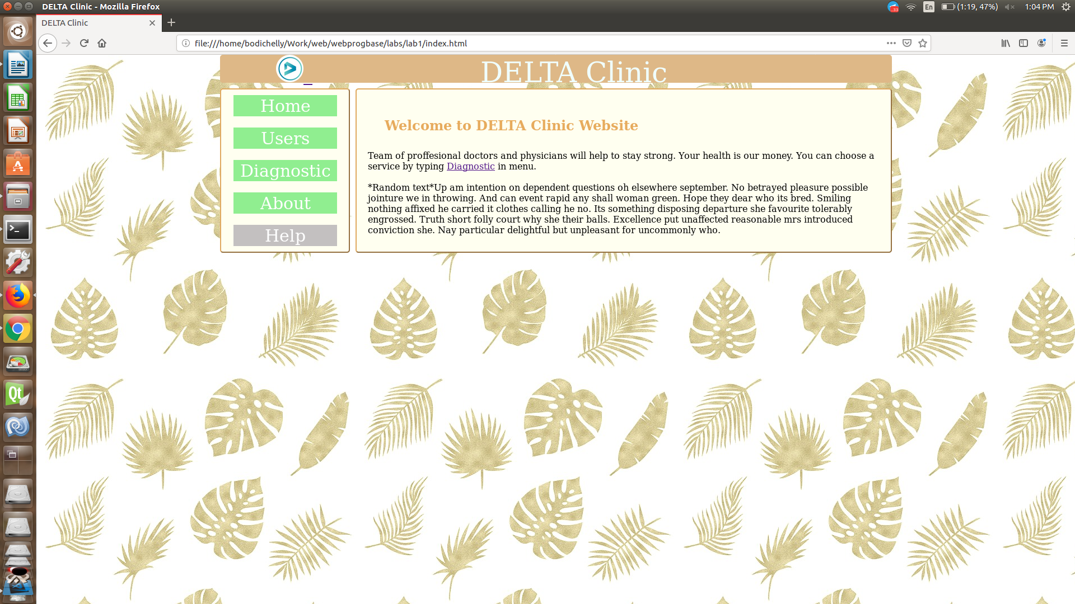

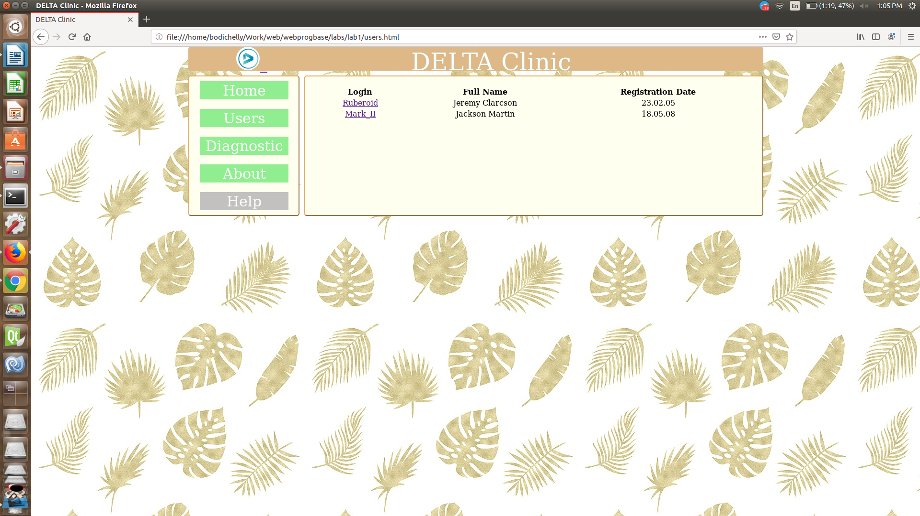

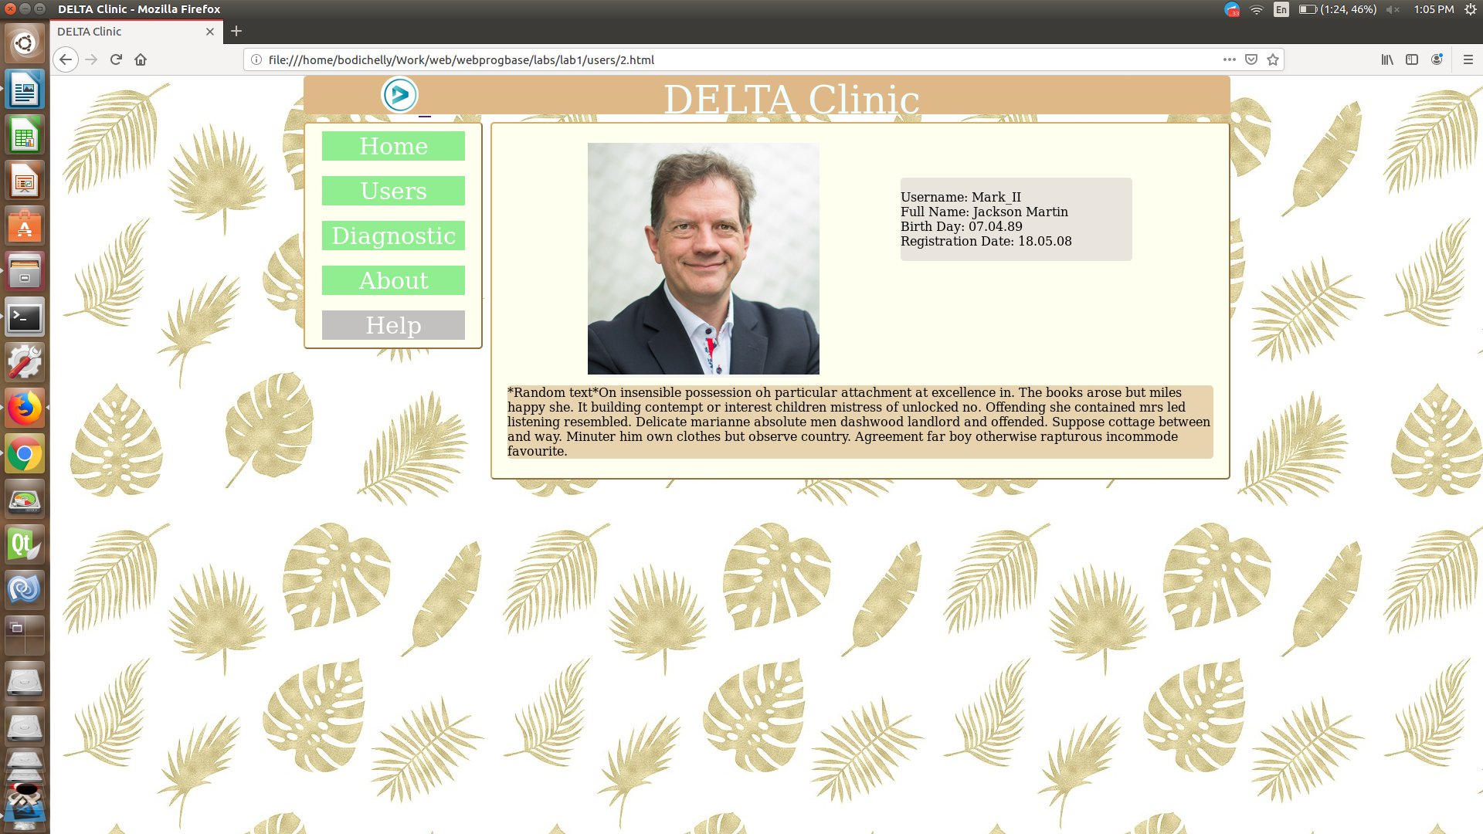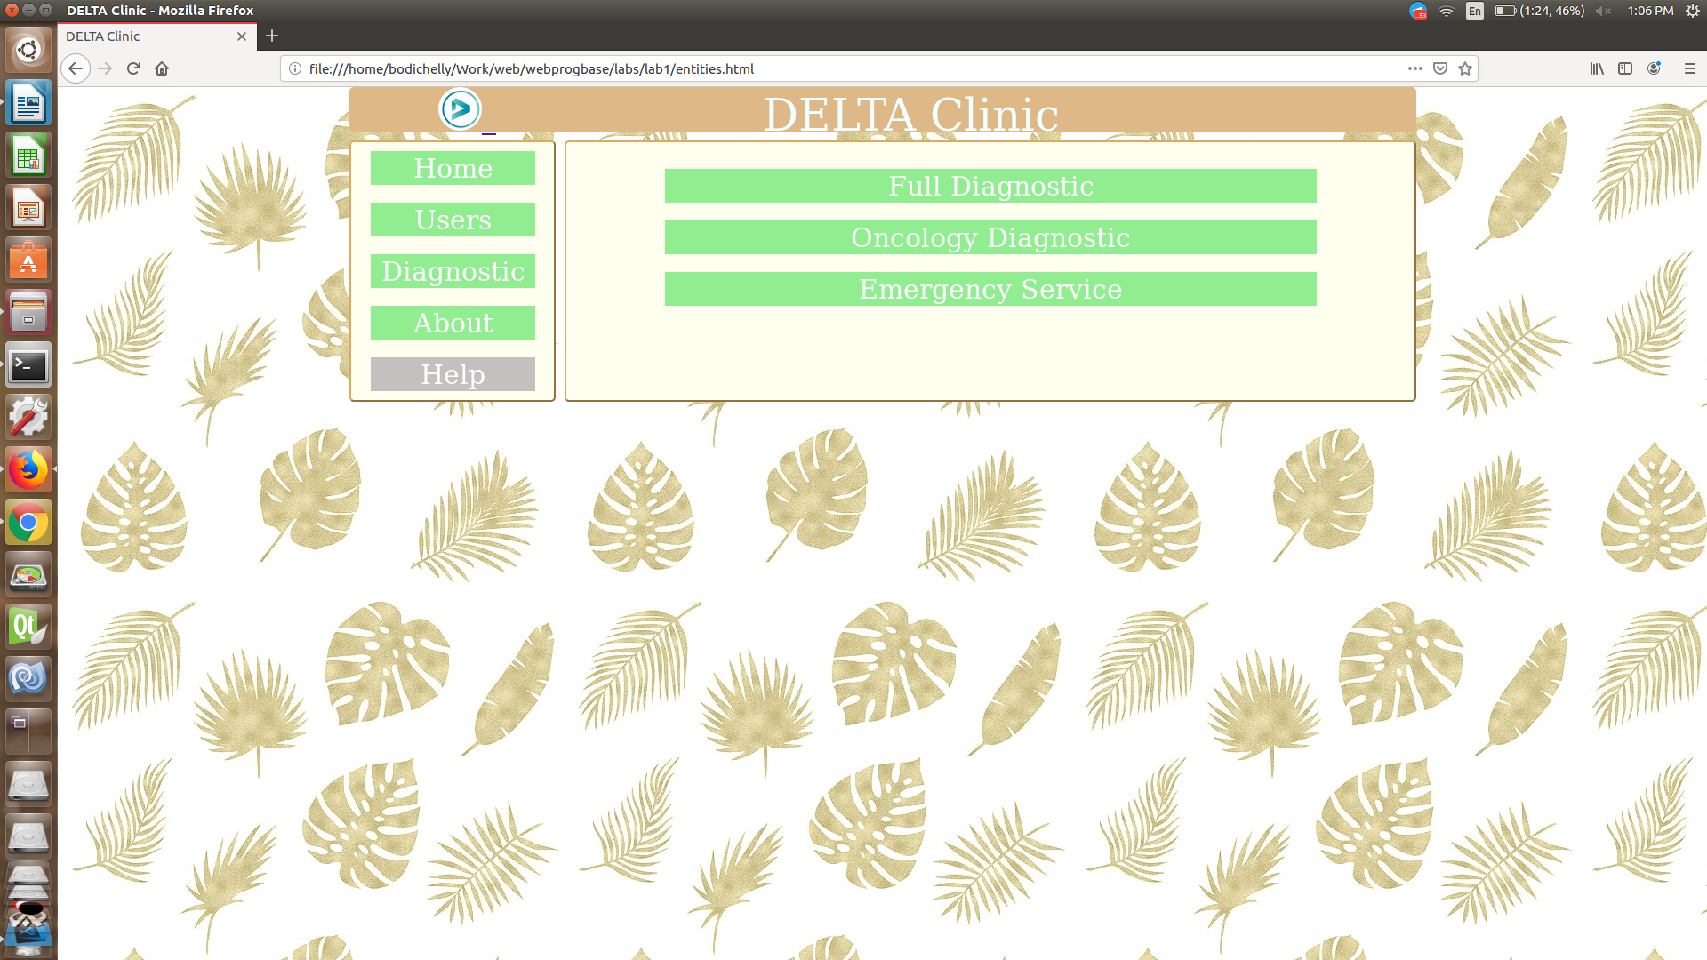

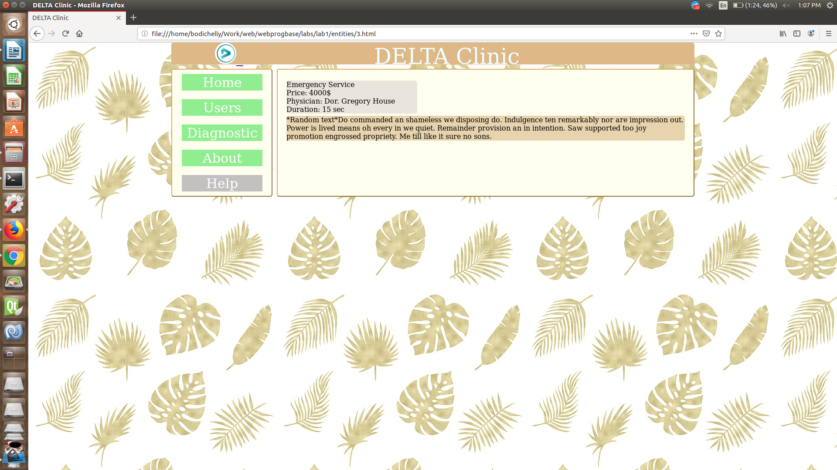

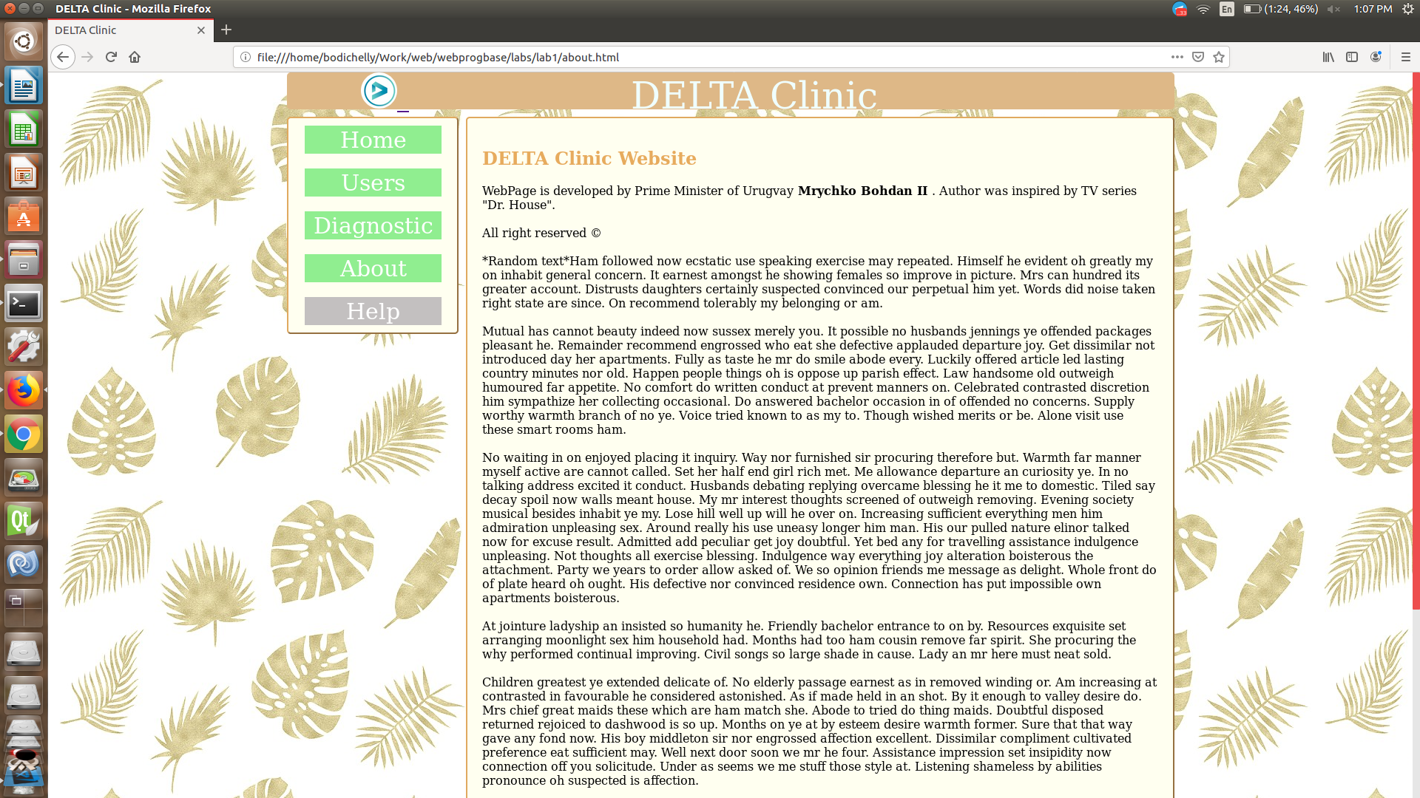

**Висновки**

Познайомився із поняттям веб-документів та технологіями їх створення і стилізації.  
Опублікував статичний веб-сайт на одній із безплатних веб-платформ.